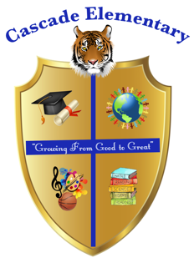

Cascade Elementary Website
Weekly Grade Level News Blast

Week of: April 27, 2020

Grade Level: 3rd

Standards of the Week:
Language Arts - L1a - Explain the function of adverbs in general and their functions in particular sentences.

Reading – RL9 - Compare and contrast the themes, settings, and plots of stories written by the same author about the same or similar characters (e.g., in books from a series).

Math – MD2 - Measure and estimate liquid volumes and masses of objects using standard units of grams (g), kilograms (kg), and liters (l).

Science – P1 - Obtain, evaluate, and communicate information about the ways heat energy is transferred and measured.
Social Studies – E1 - Define and give examples of the four types of productive resources. a. Natural (land) b. Human (labor) c. Capital (capital goods) d. Entrepreneurship (risk-taking and combining natural, human, and capital resources in an attempt to make a profit)

Additional Information for Parents and Students:
- Check the 3rd Grade WeatherWise GoogleClassroom daily
- No School on Friday – Teachers are available if needed
- Daily Zoom meeting with teachers @ 10:00 am
- Email
  - Ms. Cook – tsbell@atlanta.k12.ga.us
  - Ms. Diggins - Courtni.Diggins@atlanta.k12.ga.us
  - Mr. Mills - wmills@atlanta.k12.ga.us
  - Ms. Peete - nopeete@atlanta.k12.ga.us

